What California’s Leaders Must Do Next to Advance Student Learning During COVID-19.

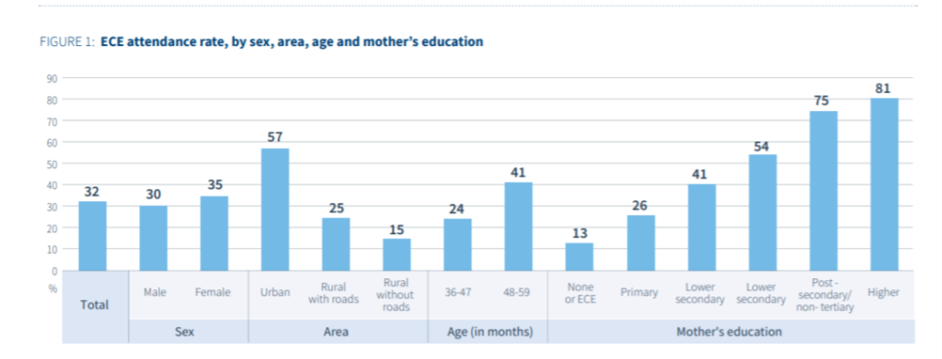

**Summary**

On July 17th, 2020, Governor Newsom introduced that every one K–12 colleges in California counties with growing COVID-19 infections might be required to educate remotely. Without a sturdy consciousness on enhancing the nice of far off training at scale, college students ought to lose as much as a year’s really well worth of mastering, and as many as 1.1 million college students ought to fail to graduate excessive faculty. That educational effect might be felt maximum acutely via way of means of low-earnings, Black, and Latinx college students. California’s leaders ought to act now to prioritize fairness and make sure nice throughout all the country’s districts. New guidelines do set up baseline statewide coaching and mastering necessities, however those expectancies may be bolstered. State leaders ought to make sure ok monitoring, assist, and resources, all with deep interest to fairness. Absent those things, we are able to assume to peer even extra troubling variations in possibility and success rise up amongst districts, colleges, and organizations of college students.

* Learn extra approximately those topics:
* Continuous faculty improvement & assist
* Educational governance & policy
* Supporting college students’ social-emotional, mental & bodily fitness

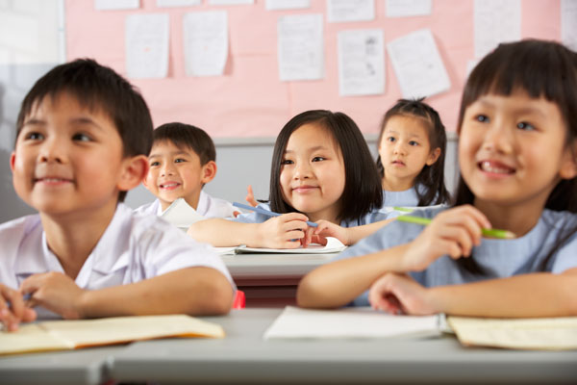

**Introduction**

When colleges reopen for the 2020–21 faculty year, they may appearance dramatically exceptional than earlier than the pandemic. Whether in person, online, or a few aggregate of the two, it'll be vital that every pupil gets rigorous practise and the educational, social, and emotional assist had to thrive. That might be a miles cry from the emergency training maximum districts provided withinside the spring.

Data monitor extensive version in how distance mastering become implemented.1 Each district, faculty, classroom, and pupil institution skilled some thing exceptional due to college students’ numerous get entry to to computer systems and Wi-Fi; variations in nearby selections approximately what curriculum to apply and what sort of practise to offer; variations withinside the velocity with which districts ramped up their digital mastering; and variations in efforts to satisfy the desires of English inexperienced persons (ELs), college students with disabilities, college students who had been at the back of academically, and college students with fewer helps at home.2 Nationally, most effective one in 5 districts added rigorous distance practise.three In California, English inexperienced persons and college students of colour had been a long way much less possibly to have the possibility to have interaction at once with teachers.four This is mainly troubling in a country wherein 1.15 million college students are ELs, representing one out of each 3 ELs withinside the country,five and wherein extra than 3 quarters of college students are college students of colour.6

When college students go back to high school, our country’s expectancies for practise must be a long way better. California leaders ought to prioritize fairness and make sure nice throughout the country’s kind of 1,000 faculty districts. The implications, otherwise, can be dire. McKinsey and Company lately warned that if low-nice far off mastering maintains in 2020–21, college students ought to lose as much as a year’s really well worth of mastering and excessive faculty dropouts ought to boom via way of means of as many as 1.1 million college students.7 That educational slide might be felt maximum acutely via way of means of low-earnings, Black, and Latinx college students.

They had been those least possibly to get a wonderful training each earlier than and in the course of the pandemic. Further, the fitness and financial influences of COVID-19 have disproportionately affected their families.eight In 2020–21, those and different inclined college students ought to acquire suitable practise, everyday interactions with teachers, and helps that cope with their educational, psychological, and social-emotional desires.9

New country guidelines offer a few much-wanted guardrails via way of means of organising baseline statewide necessities associated with coaching and mastering.10 However, those expectancies may be bolstered and via way of means of themselves aren't enough. Next, country leaders ought to make sure ok monitoring, assist, and resources, all with deep interest to fairness. Absent the ones things, we are able to assume to peer even extra troubling variations in possibility and success rise up among districts, colleges, and organizations of college students.

No doubt, civil rights and training fairness advocates will maintain to reveal the state of affairs and could reply to inequities in how pupil organizations are served. To get in advance of this and fortify assurances concerning nice and fairness, the legislature and governor ought to paintings in near coordination with the California Department of Education (CDE); the State Board of Education; the California Collaborative for Educational Excellence; California’s better training, fitness, and welfare systems; statewide associations; hard work partners; and a vast variety of country and nearby advocacy organizations along with the ones representing college students and parents.

This quick presents tips to policymakers on an appropriate country position in assisting coaching and mastering because the pandemic maintains, calling at the country to:

* set up a small wide variety of clean necessities associated with coaching and mastering, reveal their implementation, and offer assist to districts to assist them cope with college students’ educational, social, and emotional desires;
* enlarge districts’ key flexibilities, constant with fairness imperatives, so districts can efficiently, effectively, and creatively serve college students; and
* play a management position in securing extra funding.

Before discussing those tips, we in brief overview what the country has carried out up to now in regard to high school reopening and why it's so severely vital to bolster usually country management in this issue.

**Conclusion**

Our educators and nearby training leaders have validated exceptional management and resilience in the course of an unparalleled time of challenge. But because the latest movements for racial justice have validated, our training device is grappling with extra than only a fitness disaster. Black and Latinx college students include the bulk of our country’s pupil population. By any measure, their academic desires had been underserved previous to the pandemic. Our training device’s reaction to COVID-19 ought to now no longer toughen and deepen the structural inequities and racism that contributed to those disparities. To cope with the present day disaster and additionally maintain California’s efforts to shut possibility and success gaps, sturdy country-stage management is wanted. By putting excessive expectancies for mastering, at the side of enough and equitable helps, our country leaders can make sure that significant mastering maintains thru this pandemic and that scholars of colour, English inexperienced persons, low-earnings college students, unique training college students, and all different inclined organizations have equitable possibilities to succeed.

**Contact Us**

Phone: 4157386899, 603 865-7345

Email: educationdigest9@gmail.com

Skype: WELLNESSAIRE